

Dr. Andrew, Ryan inc.
2019-04-14
Dr. Ryan
084 Williams Route, Port Jacob, MT 78408
Phone: 4808650430
Fax: 654328250

Re: Courtney, Roberts
PHN: 5151539638
Birthdate: 18-Oct-1985
Address: 711 Johnson Valley Suite 751, Chelseaborough, NY 33049
Patient number: 6133417276

To Whom It May Concern:

This is a medical letter to state the above patient is pregnant with expected delivery date of 25-Sep-2025. Hoping this information is satisfactory for your requirements.

Thank you.

Sincerely,
Dr. Andrew, Ryan
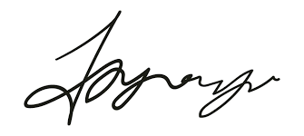
FRCS© NCMP
Clinical Assistant Professor, UBC
Department of Obstetrics and Gynecology SMH

